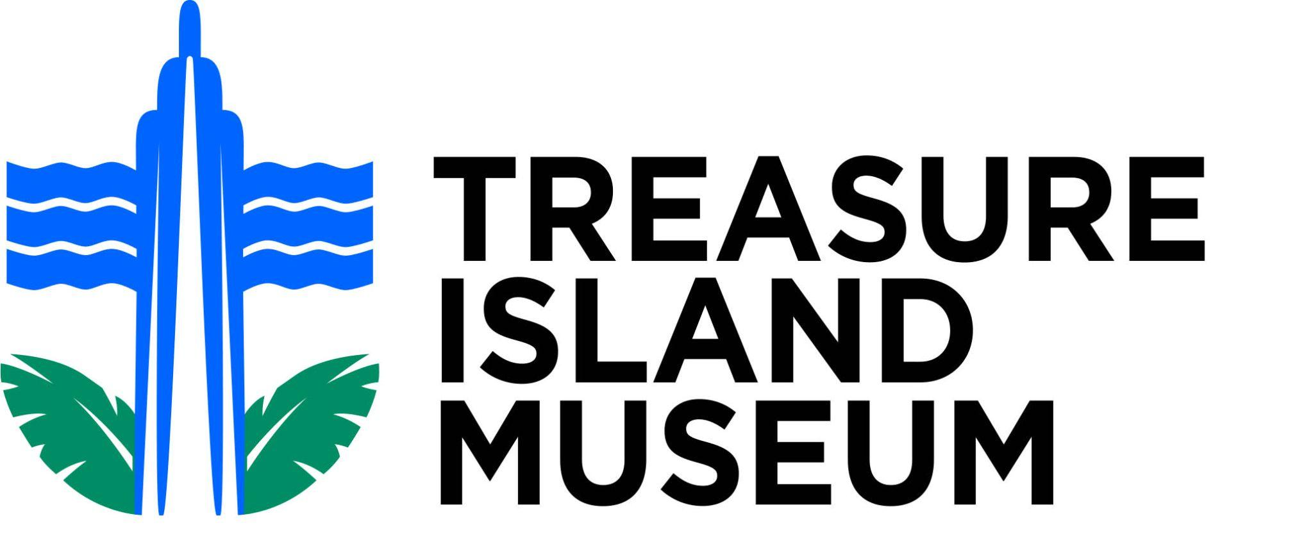
SELF-GUIDED TOUR

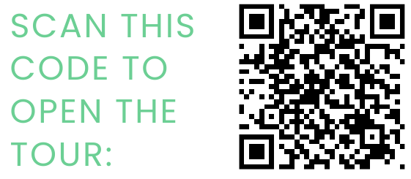
To view the map and get directions for this self-guided tour, please scan the QR code here or go to www.treasureislandmuseum.org/self-guided-tour

Driving Tour Sites
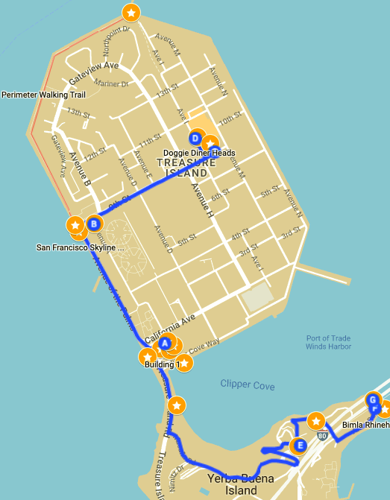
Treasure Island
- Building One/Administration Building (Pacific Unity Statues, Mural, Ferry)
- Clipper Cove (Port of Trade Winds Beach, Treasure Island Marina)
- San Francisco Skyline Vista (Signal/Public Art, Perimeter Path)
- Doggie Diner Heads
- YMCA Mural
Yerba Buena Island
- Nimitz House Naval Quarters
- Bimla Rhinehart Vista Point (San Francisco Bay Bridge)
- Torpedo Assembly Building

For directions through Google Maps, and for additional information about sites, please follow the link to the self-guided tour above!

Treasure Island Sites

Building One (Administration Building)
Directions: (Address: No. 1 Avenue of the Palms)
From the East Bay, take the Bay Bridge to the Treasure Island/Yerba Buena Island exit, located on the far right side of the bridge. At the end of the offramp, turn right onto Macalla Road. Follow Macalla Road down the hill to Treasure Island Road. Turn right on Treasure Island Road. At the bottom of the hill you will see Building One, a semicircular building, on your right. Turn into the parking lot.
From San Francisco, take the Bay Bridge eastbound. The Treasure Island/Yerba Buena Island exit is located on the far left side of the bridge. Follow the ramp around Yerba Buena Island to Treasure Island. At the bottom of the hill you will see Building One, a semicircular building, on your right. Turn into the parking lot.
Parking: Park in front of Building One in the parking lot in one of the spaces marked "Visitor Parking'' for up to 2 hours on weekdays. On weekends permit parking spaces are also free to all visitors.

Highlights:
- Pacific Unity Sculptures (Outside Building One) The four statues in front of the building are from the Golden Gate International Exposition World’s Fair. Learn more by using the QR codes next to the statues!

- Treasure Naval History Mural (Inside Building One) The Lowell Nesbitt mural in the lobby depicts the history of the Navy in the Pacific. It was painted in 1975 for the U.S. Bicentennial, when this was the Administration Building for the Naval Station on Treasure Island.

- Treasure Island Ferry Terminal Take the scenic route to Treasure Island and back! The ferry ride is just 10 minutes from San Francisco’s Embarcadero, and runs from 6:30am-9:30pm (Mon-Fri), and 9am-10pm (Sat-Sun & Holidays).
ADDRESS: Across Avenue of the Palms from Building One

Clipper Cove
Directions: Located to the right (southeast) of Building One (when you are facing the building), take a short walk on the sidewalk along Clipper Cove towards Port of Tradewinds/Clipper Cove Beach.

Highlights:
- Treasure Island Marina
- Port of Trade Winds Beach/Clipper Cove Beach

San Francisco Skyline Vista
Directions: By car or on foot, travel northwest on Avenue of the Palms (western perimeter road on Treasure Island) less than half a mile to the intersection with 9th Street. Free parking is available in the lot behind the restaurant Mersea. Across Avenue of the Palms you will see a walking path (Perimeter Walking Path).

Highlights:
- Mersea Restaurant address: 699 Avenue of the Palms
- From the Perimeter Path you can see the San Francisco skyline, the Bay Bridge, Alcatraz, and the Golden Gate Bridge! Follow the path north along the shoreline from that point and soak in the views.
- Signal (Public Art) "Signal" is a public art piece by Tom Loughlin made from repurposed steel from the East bound span of the old Bay Bridge. This is significant to the history of the Golden Gate International Exposition because the fair commemorated the building of the original Bay and Golden Gate bridges. Visible from the intersection of Avenue of the Palms and Ninth Street.
- Historical Landmark A bronze plaque located in the parking lot behind Mersea marks Treasure Island as California Historical Landmark No. 987, designated in 1989. The marker provides an overview of the history of Treasure Island.
- Perimeter Walking Path/East Bay Vista Follow the walking path around the northwest corner of the island to enjoy a half-mile walk and the East Bay Skyline Vista at the end of the Perimeter walking trail. It provides a beautiful view of the East Bay and cargo ships.

Doggie Diner Heads
Directions: Drive or walk east on Ninth street to Avenue I. The doggies have been known to migrate and sometimes travel beyond Treasure Island. Usually they are located to the left (north) of Ninth Street on Avenue I.
- A set of three dog heads, the symbol for a defunct diner chain, are mounted on a trailer that can often be spotted. Doggie Diner started in 1948 in Oakland as one of the first fast food restaurants, serving primarily hot dogs and hamburgers. https://www.doggiediner.info/

- YMCA Mural
Directions: From Ninth Street, turn left at the “T” intersection (Avenue M). Drive or walk up Ninth Street and turn left into the driveway.
- The building on your left features a large, colorful mural that portrays the history of Treasure Island.
- Created by Precita Eyes Muralists Association, Inc. in 2018, a San Francisco-based community mural arts organization devoted to enriching and beautifying urban environments through community mural collaborations. https://www.precitaeyes.org/murals-2017-18.html

Yerba Buena Island Sites

Nimitz House Naval Quarters
Directions: From Treasure Island, follow Avenue of the Palms south toward Yerba Buena Island/the Bay Bridge. Turn left at the stop sign onto Macalla Rd., follow the road up the hill and then down, under the Bay Bridge. Make a sharp left turn onto Northgate Rd. Turn right at the fork onto Whiting Way, then park (temporarily) by the side of the road.
- Enjoy the gardens and historical buildings, and read about the old “Senior Officers” Housing District, as well as the history of sea services on Yerba Buena Island on the wayside marker. The Nimitz House, also known as Quarters One, is listed on the National Register of Historic Places.
- The Nimitz House and other “Great Whites” in the area are empty and closed to the public.

Bimla Rhinehart Vista Point & the San Francisco Bay Bridge
Directions: Take the route to the Nimitz House and continue on Whiting Way, then make a sharp right onto Northgate. Turn left at Army Road, and go to the parking lot at the end of Army Road. Walk a bit to get to the site.
- Enjoy the view of this engineering marvel, the eastern span of the San Francisco-Oakland Bay Bridge, which was completed in November, 1936, six months before the Golden Gate Bridge.
- The Bimla Rhinehart Vista is built on the location of the original Pier 2 of the San Francisco/Oakland Bay Bridge. It is constructed of salvaged materials from the bridge.

Torpedo Assembly Building
Directions: After you arrive at the Bimla Rhinehart Vista, you will see the Torpedo Assembly Building on the left. The building is empty and currently closed.
- The Torpedo Assembly Building is on the National Register of Historic Places. It was built in 1891 by the U.S. Army. The building remains almost completely the same as when in use, from 1891-1960.

